Ideation Phase
Define the Problem Statements
Date | 25 JUNE 2026
Team ID | SWTID20269563
Project Name | Smart Lender
Maximum Marks | 2 Marks

Customer Problem Statement Template:
Create a problem statement to understand your customer's point of view. The Customer Problem Statement template helps you focus on what matters to create experiences people will love.
A well-articulated customer problem statement allows you and your team to find the ideal solution for the challenges your customers face. Throughout the process, you’ll also be able to empathize with your customers, which helps you better understand how they perceive your product or service.
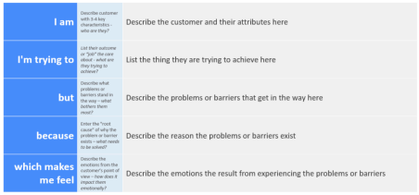Reference: https://miro.com/templates/customer-problem-statement/
Example:
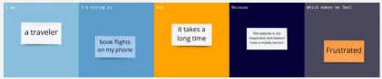
Problem  Statement (PS) | I am  (Customer) | I’m trying to | But | Because | Which makes me feel
PS-1 | a loan applicant | Get my loan approved quickly and easily | The approval process takes a long time | Manual verification and document checking are time-consuming | Frustrated and uncertain
PS-2 | A bank loan approver | Evaluate loan applications accurately an faster | There are too many applications and risk of human error | Data in different formats and verification is done manually | Overwhelmed and pressured to make correct decisions

